# *Polls and interactive modules being added post launch

# Program Contacts

|  |  |
| --- | --- |
| **TOC Writer:** | Suzanne Kayes |
| **Editor:** | Michelle Bourg/Nicole Hollimon |
| **Producer:** | N/A |
| **PM:** | Wilmar Ng |
| **AM:** | Lauren Fox |
| **SF#:** | SF301050.1 |

# [Destination Details](#MainProgramNodeProp" \o "Note to Editors: Only use letters a-z or numbers 0-9—no punctuation or special characters—in Node names and program names. Character limit 72 characters. Doesn't need to replicate the program title.)

|  |  |
| --- | --- |
| **Is Program Exclusive?** | **YES** |
| **Package Type** | **Editorial Destination** |
| **Node Name** | Lower Medication Cost |
| **Base URL** | https://www.webmd.com/health-insurance/lower-med-costs-20/default.htm |
| **Title/Breadcrumb**  ***50 Char*** | **Tips to Help You Save Money on Your Medication** |

# TOC Promo Image

|  |  |
| --- | --- |
| **Image Suggestion for Rev Design** |  |

# Content Table (in priority order)

|  |  |  |  |  |  |  |
| --- | --- | --- | --- | --- | --- | --- |
| **ID** | **[Link Text](#TitleCharCnt" \o "35 Characters) *80 Char***  ***(except Video = 50)*** | **Asset Type** | **DCTM ID** | **Full** **URL** | **Asset Budget** | **Article Image Path** |
| 1 | Simple Ways to Lower Your Medication Costs | SS | 091e9c5e81fb4888 | https://www.webmd.com/health-insurance/lower-med-costs-20/slideshow-lower-med-costs | https://sharepoint.webmd.net/consumerportals/ConsServ/Programming/Ed-Dev/Content/content/Shared%20Documents/Drugs/Destinations/SF301050_JJSymtuza_OnlinePharmacies/Drugs_SimpleWaysLowerMedicationCosts.aspx | http://img.webmd.com/dtmcms/live/webmd/consumer_assets/site_images/article_thumbnails/slideshows/simple_ways_to_lower_medication_costs_slideshow/650x350_simple_ways_to_lower_medication_costs_slideshow.jpg |
| 2 | How About a Generic? | MR | 091e9c5e81fb4889 | https://www.webmd.com/health-insurance/lower-med-costs-20/generic-meds | https://sharepoint.webmd.net/consumerportals/ConsServ/Programming/Ed-Dev/Content/content/Shared%20Documents/Drugs/Destinations/SF301050_JJSymtuza_OnlinePharmacies/MR_Drugs_GenericsOTCandprescription.aspx | http://img.webmd.com/dtmcms/live/webmd/consumer_assets/site_images/article_thumbnails/other/pharmacist_filling_prescription_pill_bottle_other/650x350_pharmacist_filling_prescription_pill_bottle_other.jpg |
| 3 | Shop Around Before You Fill Your Prescription | MR | 091e9c5e81fb488a | https://www.webmd.com/health-insurance/lower-med-costs-20/shop-around-prescriptions | https://sharepoint.webmd.net/consumerportals/ConsServ/Programming/Ed-Dev/Content/content/Shared%20Documents/Drugs/Destinations/SF301050_JJSymtuza_OnlinePharmacies/MR_Drugs_ShopAroundBeforeYouFillYourPrescription.aspx | http://img.webmd.com/dtmcms/live/webmd/consumer_assets/site_images/article_thumbnails/other/pharmacist_assisting_customer_other/650x350_pharmacist_assisting_customer_other.jpg |
| 4 | Mail-Order Pharmacies: How They Work | MR | 091e9c5e81fb488b | https://www.webmd.com/health-insurance/lower-med-costs-20/mail-order-pharmacies | https://sharepoint.webmd.net/consumerportals/ConsServ/Programming/Ed-Dev/Content/content/Shared%20Documents/Drugs/Destinations/SF301050_JJSymtuza_OnlinePharmacies/MR_Drugs_MailOrderPharmacies.aspx | http://img.webmd.com/dtmcms/live/webmd/consumer_assets/site_images/article_thumbnails/other/visiting_mail_order_pharmacy_website_other/650x350_visiting_mail_order_pharmacy_website_other.jpg |
| 5 | Patient Assistance Programs for Prescription Drugs | MR | 091e9c5e809d8184 | https://www.webmd.com/health-insurance/lower-med-costs-20/patient-assistance-programs-for-prescription-drugs | https://sharepoint.webmd.net/consumerportals/ConsServ/Programming/Ed-Dev/Content/content/Shared%20Documents/Drugs/Articles/MR_Drugs_PatientAssistancePrograms.docx | http://img.webmd.com/dtmcms/live/webmd/consumer_assets/site_images/article_thumbnails/other/paying_with_credit_card_at_pharmacy_other/650x350_paying_with_credit_card_at_pharmacy_other.jpg |
| 6 | How Do You Save Money on Meds? | Poll | N/A |  | https://sharepoint.webmd.net/consumerportals/ConsServ/Programming/Ed-Dev/Content/content/Shared%20Documents/Drugs/Tools_Add_Ons/Polls_JJXeralto_MedicationSpendingPoll.docx |  |
| 7 | How Much Do You Spend on Prescriptions a Year? | Poll | N/A |  | https://sharepoint.webmd.net/consumerportals/ConsServ/Programming/Ed-Dev/Content/content/Shared%20Documents/Drugs/Tools_Add_Ons/Polls_JJXeralto_MedicationSpendingPoll.docx |  |

# Launch Poll

|  |  |
| --- | --- |
| **Question** | Which of these tips do you feel would be most beneficial in helping you save money on medication? |
| **Answers** | * Buy generics * Use a mail-order pharmacy * Shop around and ask pharmacies to match competitor’s prices * Apply for a Patient Assistance Program (PAP) * Use a preferred pharmacy |

# Refresh Poll

|  |  |
| --- | --- |
| **Question** | How much do you currently spend on prescription medications per year? |
| **Answers** | * $0 - $250 * $251-$500 * $501-$750 * $751-$1000 |

## TOC Page Configuration

|  |  |
| --- | --- |
| **Link Title** | Content on How to Save Money on Your Medication |
| **Window Title** | Content on How to Save Money on Your Medication |
| **Content Classification** | TOC |
| **WebMD Keywords** | lower drug costs |
| **User & Meta Description** | Content on How to Save Money on Your Medication |
| **Internally Searchable** | YES |
| **Externally Searchable** | YES |
| **Publication** | **Pharma: WebMD Patient Solutions Center CPG: WebMD Healthy Living Center** |
| [**Primary Topic**](https://sharepoint.webmd.net/consumerportals/ConsServ/Lists/PrimaryTopicIDs/PrimaryTopics-by-Name.aspx) **ID** | Health Insurance and Affordable Care Act |

### TOC Module Configurations

#### TOC Module Options

|  |  |  |
| --- | --- | --- |
| **Single Hero** | **Double Hero** | **Triple Hero** |
|  |  |  |
| Single Tile | Poll | Tips |
|  |  |  |

#### TOC Tile Configuration

|  |  |  |  |  |
| --- | --- | --- | --- | --- |
| **Position** | **Module Type** | **Module Content** | | |
| Row 1 | Single Hero | 1 |  |  |
| Row 2 | Single Tiles | 2 | 3 | 4 |
| Row 3 | Single Tiles | 5 |  |  |

## Article, Tool and Video Page Configurations

#### Additional Information – 9 Tile Max

|  |  |
| --- | --- |
| **Header Text *50 char*** | More on Lowering the Cost of Medication |
| Link Order | Link |
| 1 | 1 |
| 2 | 2 |
| 3 | 3 |
| 4 |  |
| 5 |  |
| 6 |  |

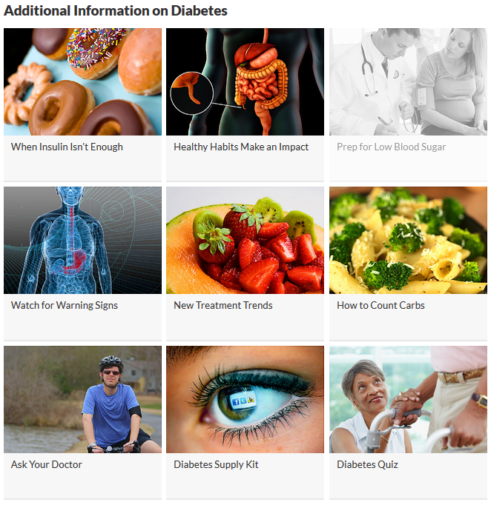

#### 

## See All Page

|  |  |
| --- | --- |
| **Page Name** | 99 See All Page |
| **Link Title** | See All: Content on How to Save Money on Your Medication |
| **Window Title** | Content on How to Save Money on Your Medication |
| **Friendly URL** | index |
| **Content Classification** | Index |
| **WebMD Keywords** | lower drug costs |
| **User & Meta Description** | INDEX: Content on How to Save Money on Your Medication |
| **Internally Searchable** | YES |
| **Externally Searchable** | YES |
| **Publication** | **Pharma: WebMD Patient Solutions Center CPG: WebMD Healthy Living Center** |
| [**Primary Topic**](https://sharepoint.webmd.net/consumerportals/ConsServ/Lists/PrimaryTopicIDs/PrimaryTopics-by-Name.aspx) **ID** | **Same as Center program lives in.** |

# Redirects

(Funded to funded -- no SS/RMQ/Video/exclusive content; Release to site)

|  |  |
| --- | --- |
| From Full URL | To Full URL |
| N/A |  |

**Interactive modules**

**Requirements:**

Image: **Image path**, **caption** (40-char max with spaces), **placement** (left for small thumbnail, middle for large thumbnail)

Quote: **Quote and attribution** (280-char max with spaces total)

Shareable Fact: **Header** (Did You Know is preferable; can be edited), 280 characters max, attribution optional, middle placement ideal

Bulleted List: **Header** (80-character max with spaces), **optional paragraph intro** (120-char max with spaces), **bulleted items** (40-char max with spaces), **optional bullet text** (80-char max with spaces), **placement** (left is preferred).

Slideshow: **DCTM ID, placement** (left is preferred)

Video: **DCTM ID**, optional **headline** (60-char max with spaces), optional **description** (120-char max with spaces), **placement** (left or middle)

|  |  |  |
| --- | --- | --- |
| DCTM ID | MODULE 1 | MODULE 2 |
| 091e9c5e81fb488b | Type: Pull Quote  Details: Mail-order pharmacies are a great choice for “maintenance drugs,” or prescriptions you take regularly, such as birth control pills or blood pressure meds.  Where in article: Between first and second graf  Left or middle: Left | Type: Image  Details:  Where in article: Between 6th and 7th graf  Left or middle: Left |
| 091e9c5e81fb4889 | Type: Pull Quote  Details: When surveyed, 91% of pharmacists said they buy generic, store-brand headache remedies instead of brand-name ones.  Where in article: Between 5th and 6th graf  Left or middle: Left | Type: Image  Details:  Where in article: Between 6th and 7th graf  Left or middle: Left |
| 091e9c5e81fb488a | Type: Shareable Fact  Details: According to a 2019 Consumer Reports survey, 30% of Americans who currently take a prescription drug regularly say their out-of-pocket cost for that drug had gone up in the previous year. Of those, 12% said their costs went up by $100 or more.  Where in article: Between 1st and 2nd graf  Left or middle: Left | Type: Image  Details:  Where in article: Right above “Ask About Generics” subhed  Left or middle: Left |
| 091e9c5e809d8184 | Type: Pull quote  Details: RxAssist.org, a nonprofit group, has a comprehensive directory of drug assistance programs.  Where in article: After 2nd graf  Left or middle: Left | Type: Image  Details:  Where in article: right above “Assistance Programs Run by Nonprofit Groups” subhed  Left or middle: Left |